**Week 5 – Microservices with API Gateway SupersetId-6431499**

**Name : Balaji V**

**Exercise 1: Creating Microservices for Account and Loan**

**Account Microservice:**

**Code:**

**Account.java:**

package com.cognizant.account.model;

public class Account{

private String number;

private String type;

private double balance;

public Account(){

}

public Account(String number,String type,double balance){

this.number=number;

this.type=type;

this.balance=balance;

}

public String getNumber(){

return number;

}

public void setNumber(String number){

this.number=number;

}

public String getType(){

return type;

}

public void setType(String type){

this.type=type;

}

public double getBalance(){

return balance;

}

public void setBalance(double balance){

this.balance=balance;

}

}

**AccountController.java:**

package com.cognizant.account.controller;

import com.cognizant.account.model.Account;

import org.springframework.web.bind.annotation.GetMapping;

import org.springframework.web.bind.annotation.PathVariable;

import org.springframework.web.bind.annotation.RequestMapping;

import org.springframework.web.bind.annotation.RestController;

@RestController

@RequestMapping("/accounts")

public class AccountController{

@GetMapping("/{number}")

public Account getAccount(@PathVariable String number){

return new Account("0998798797342", "savings", 234343);

}

}

**AccountServiceApplication.java:**

package com.cognizant.account;

import org.springframework.boot.SpringApplication;

import org.springframework.boot.autoconfigure.SpringBootApplication;

@SpringBootApplication

public class AccountServiceApplication{

public static void main(String[] args){

SpringApplication.run(AccountServiceApplication.class, args);

}

}

**application.properties:**

server.port=8080

spring.application.name=account-service

**Loan Microservice:**

**Loan.java:**

package com.cognizant.loan.model;

public class Loan{

private String number;

private String type;

private double loan;

private int emi;

private int tenure;

public Loan(){

}

public Loan(String number,String type,double loan,int emi,int tenure){

this.number=number;

this.type=type;

this.loan=loan;

this.emi=emi;

this.tenure=tenure;

}

public String getNumber(){

return number;

}

public void setNumber(String number){

this.number=number;

}

public String getType(){

return type;

}

public void setType(String type){

this.type=type;

}

public double getLoan(){

return loan;

}

public void setLoan(double loan){

this.loan=loan;

}

public int getEmi(){

return emi;

}

public void setEmi(int emi){

this.emi=emi;

}

public int getTenure(){

return tenure;

}

public void setTenure(int tenure){

this.tenure=tenure;

}

}

**LoanController.java:**

package com.cognizant.loan.controller;

import com.cognizant.loan.model.Loan;

import org.springframework.web.bind.annotation.GetMapping;

import org.springframework.web.bind.annotation.PathVariable;

import org.springframework.web.bind.annotation.RequestMapping;

import org.springframework.web.bind.annotation.RestController;

@RestController

@RequestMapping("/loans")

public class LoanController{

@GetMapping("/{number}")

public Loan getLoan(@PathVariable String number){

return new Loan("H0098798797342", "car", 480000, 3258, 18);

}

}

**LoanServiceApplication.java:**

package com.cognizant.loan;

import org.springframework.boot.SpringApplication;

import org.springframework.boot.autoconfigure.SpringBootApplication;

@SpringBootApplication

public class LoanServiceApplication{

public static void main(String[] args){

SpringApplication.run(LoanServiceApplication.class, args);

}

}

**application.properties:**

server.port=8081

spring.application.name=loan-service

**Output:**

**Account Microservice**

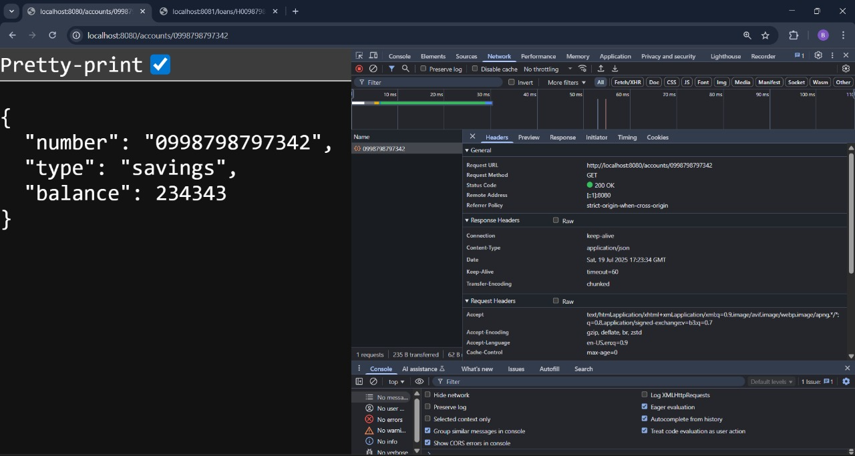

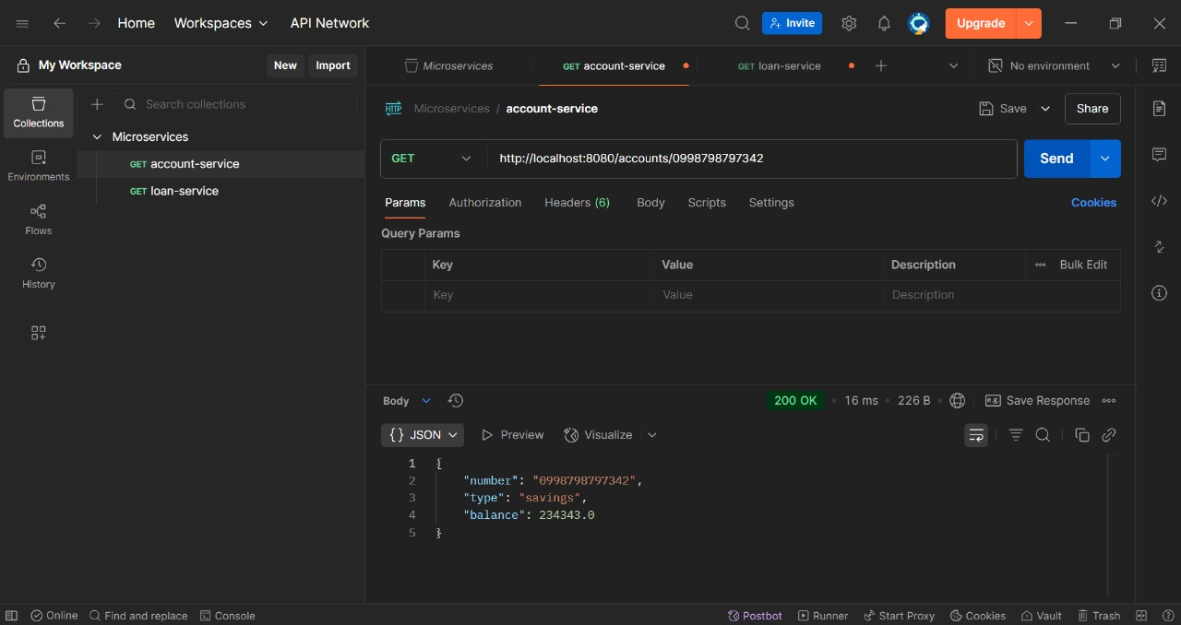

**Loan Microservice**

